WEEK 1 – TASK

**Creating Inventory, Manufacturing, and Supplier Table from Sustainable Supply Chain Performance dataset using Power BI Tool.**

* Following are the steps of it:
* Step 1: Open a blank report in Power BI.

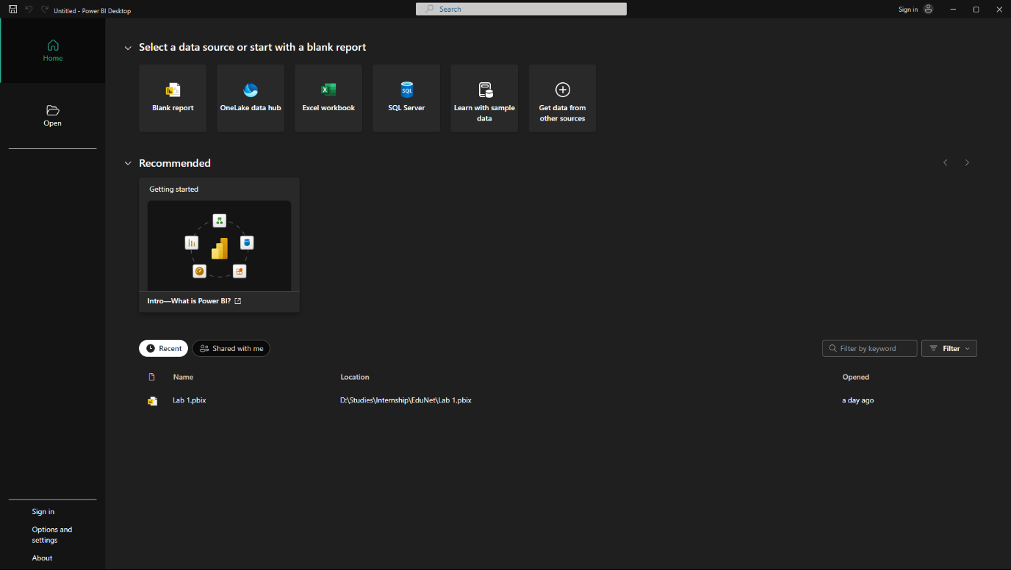

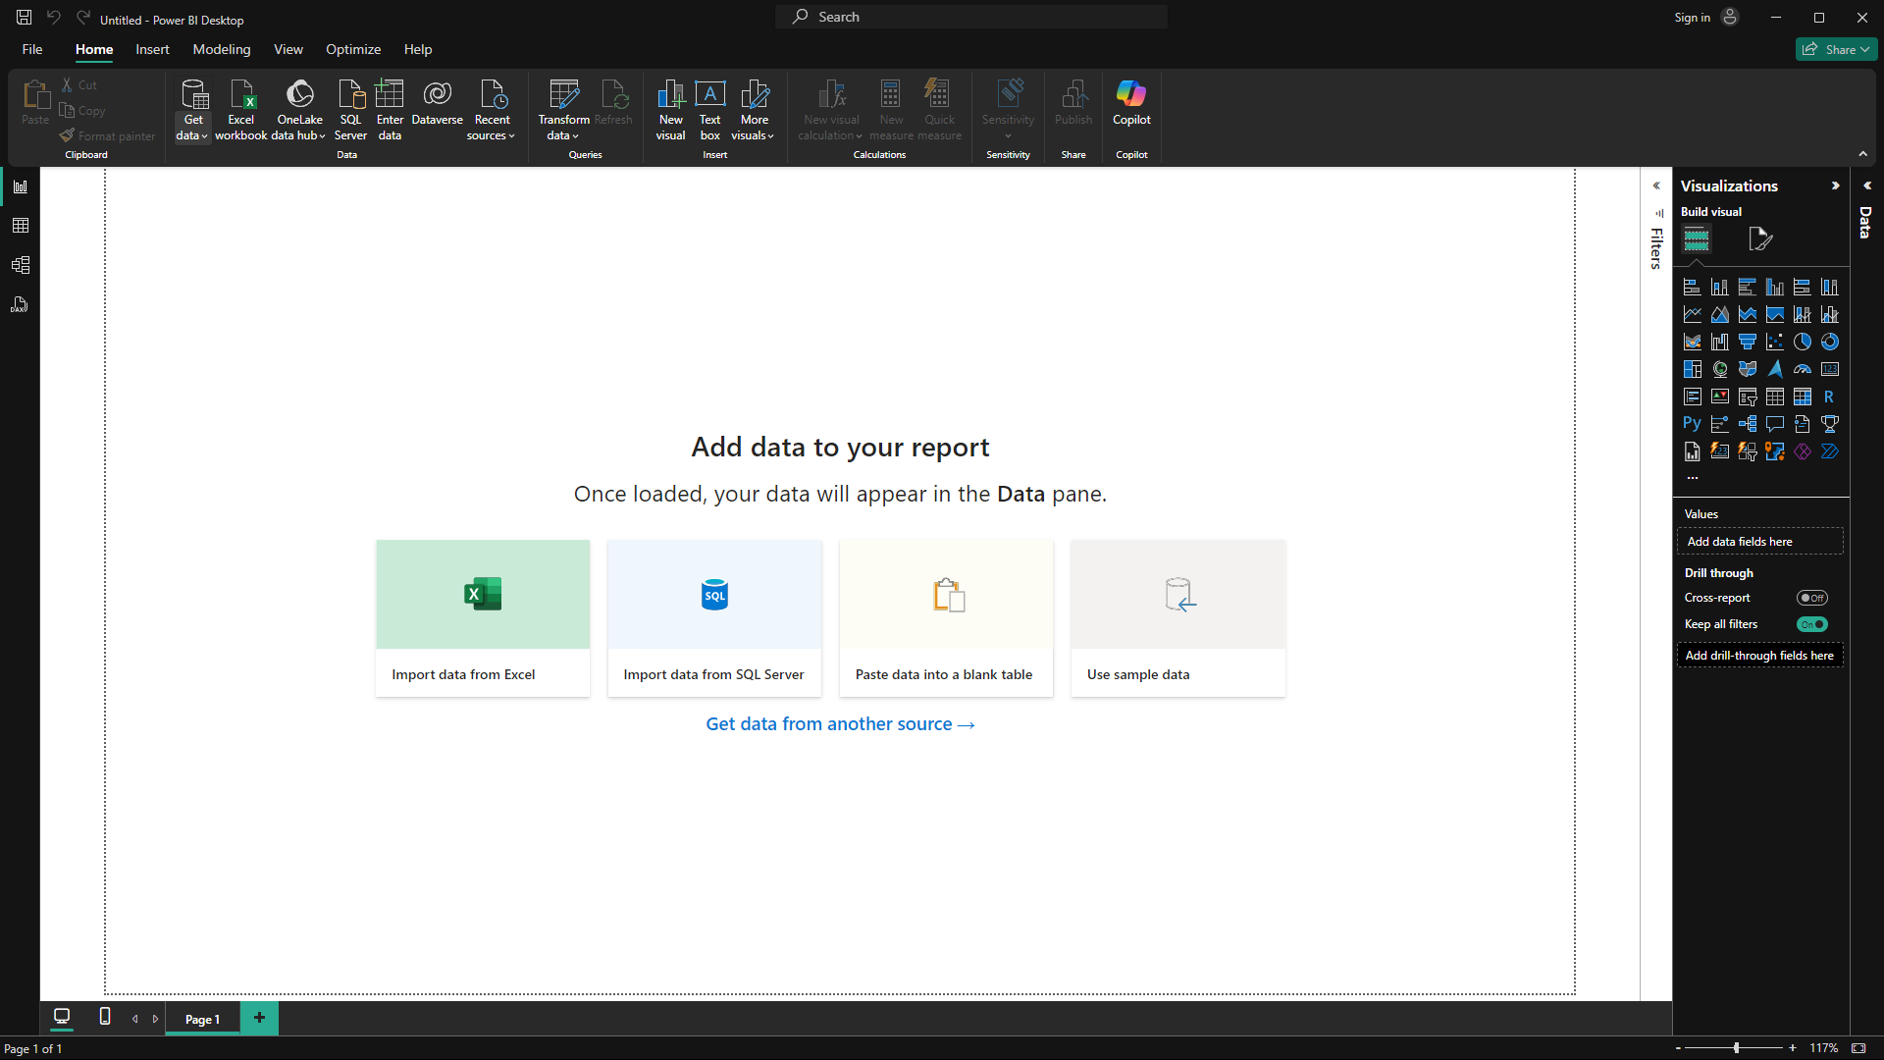

* 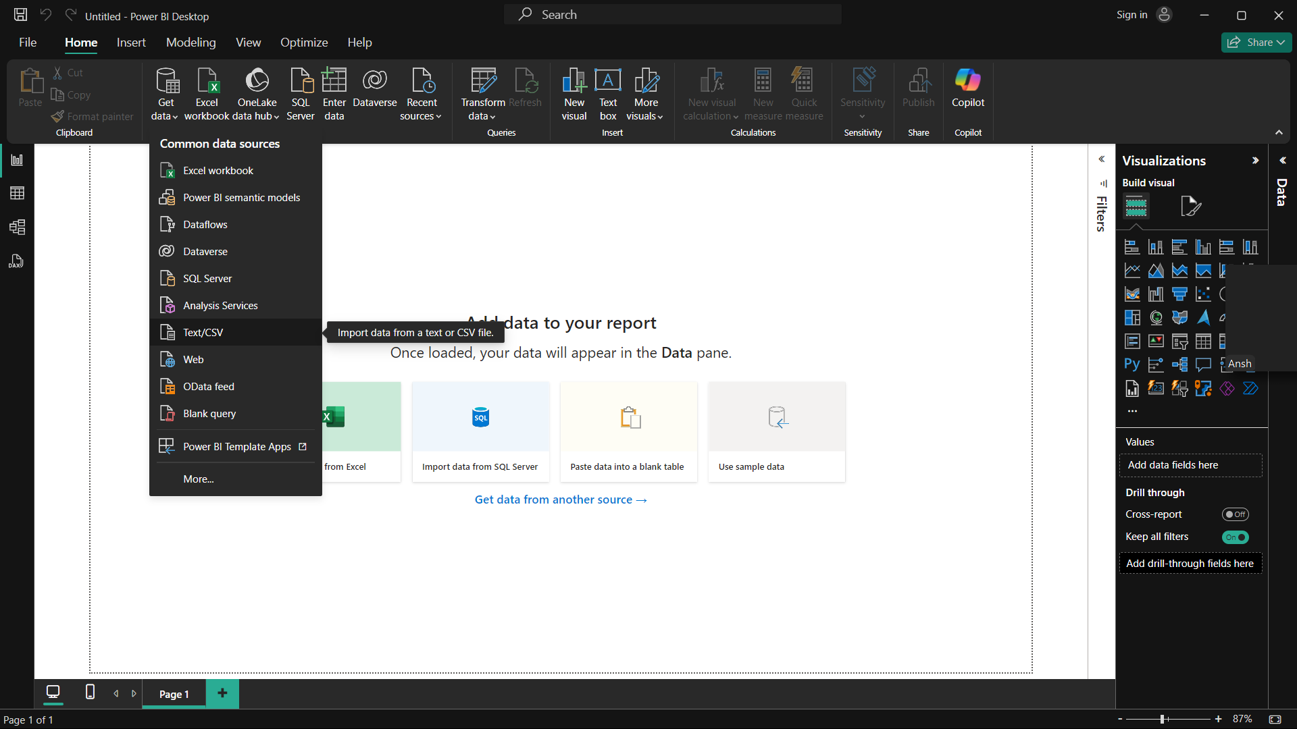Step 2: Go to Get data and import/load data by choosing the file of data. Here we have csv file so we select text/csv option.

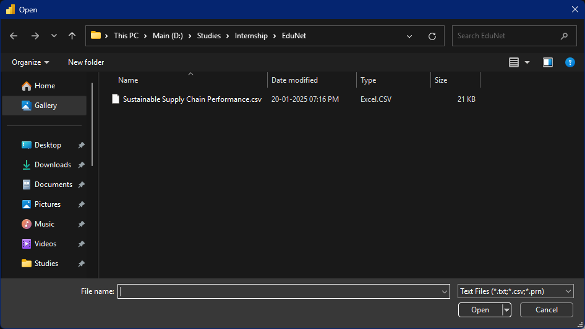

* Step 3: On opening the file, a window appears of the overview of the data, on bottom side there are three buttons, namely, Load and Transform.
  + - Load: When u know your data is cleaned of inconsistency.
    - 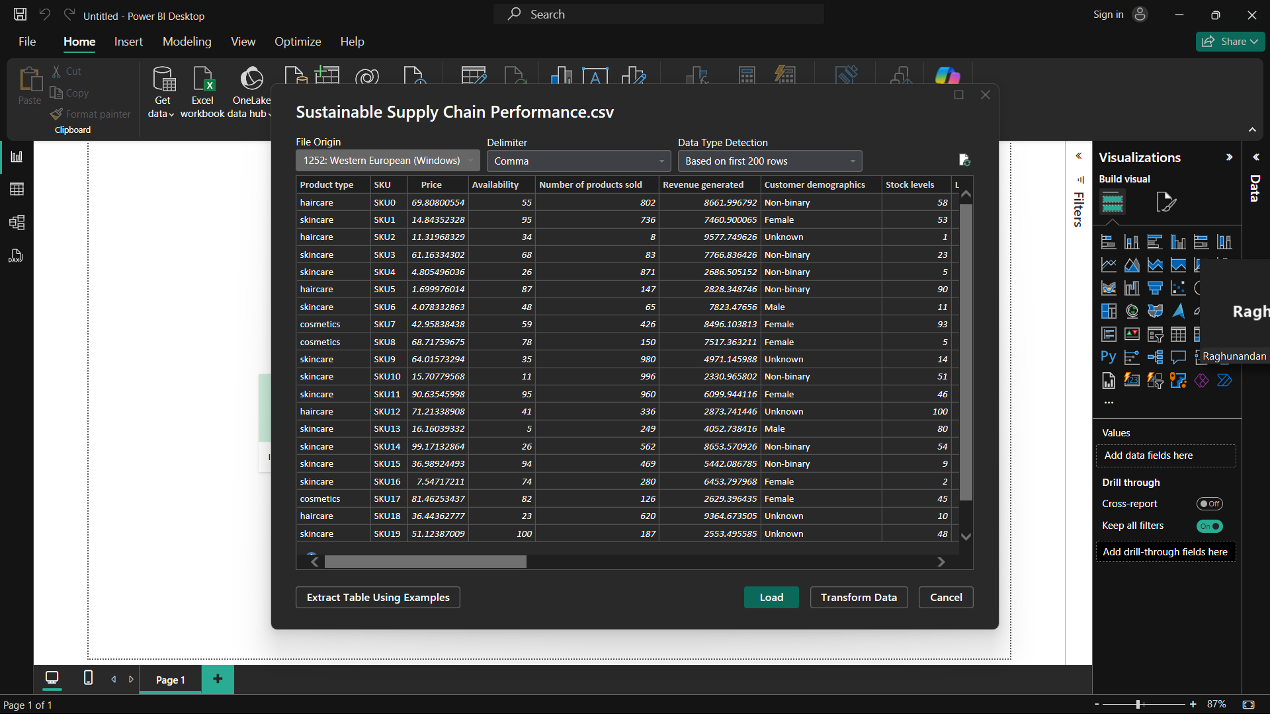Transform: When data has inconsistency.
* Step 4: Click on load button. After loading data, also we can transform data. So now clicking on transform data new window open ups.

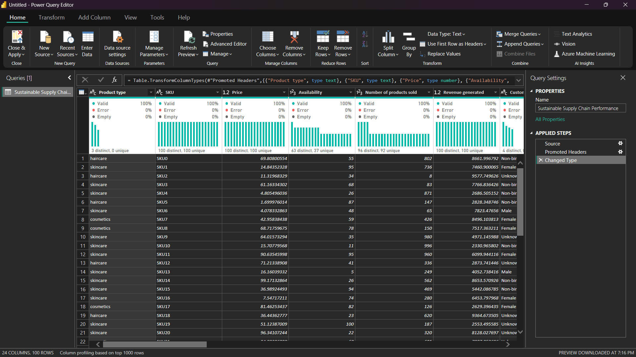

* Step 5: Right clicking on the table name on left side queries panel and duplicate it and renamed it inventory.

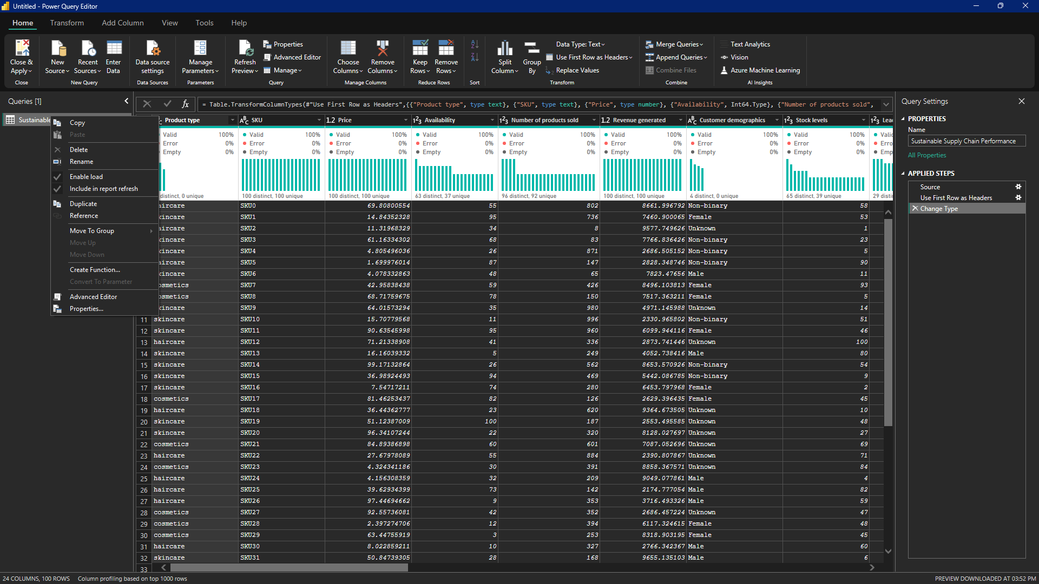

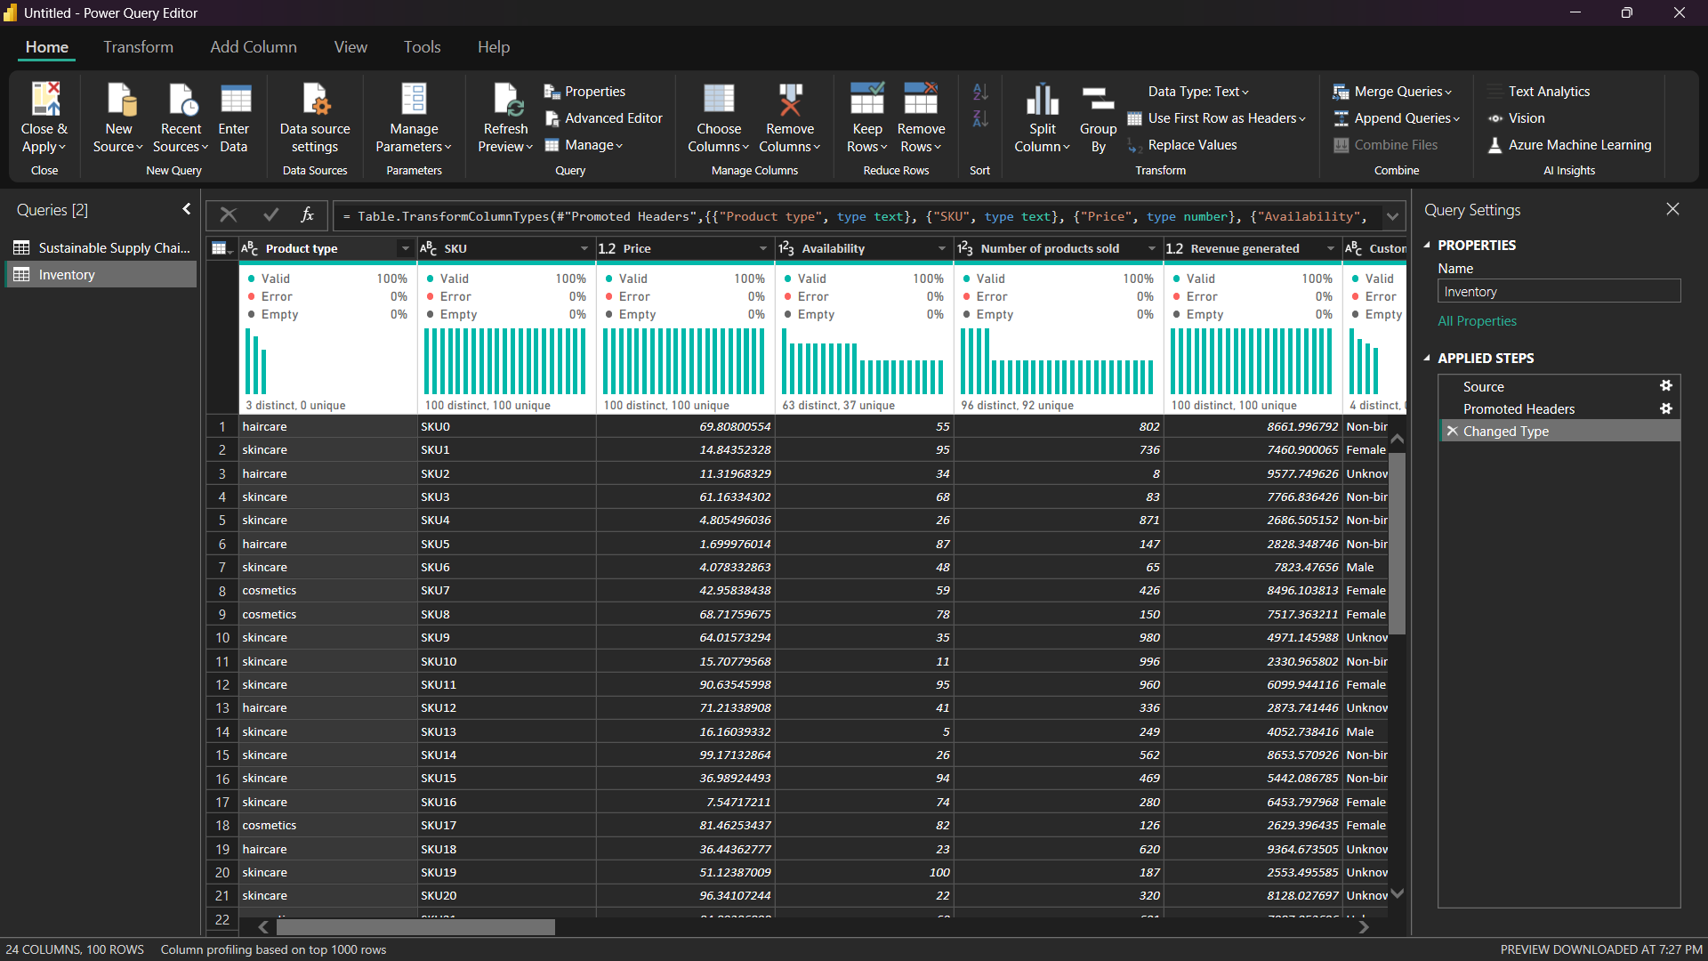

* Step 6: Remove those columns which inventory does not require.
* Step 7: Right click on the column and select remove column option.
* Step 8: Follow same steps for remaining tables.
* Step 9: Save the file.

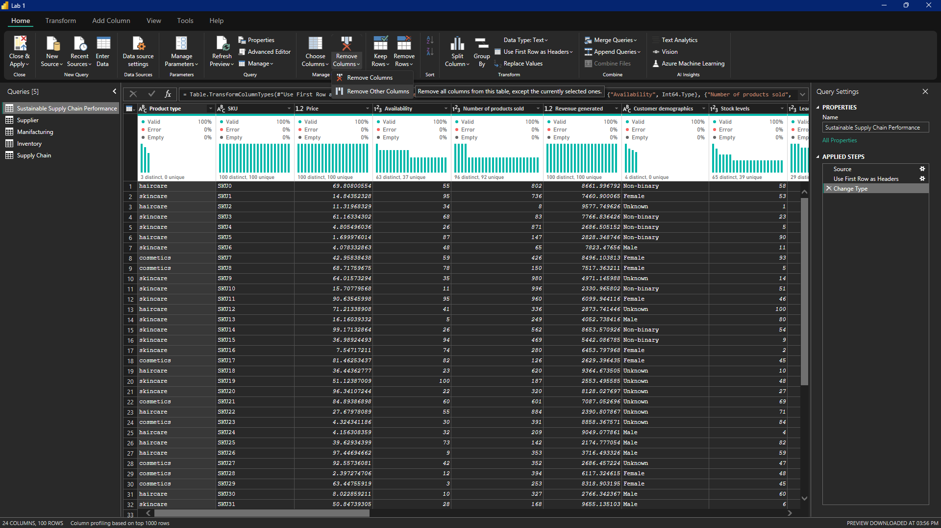

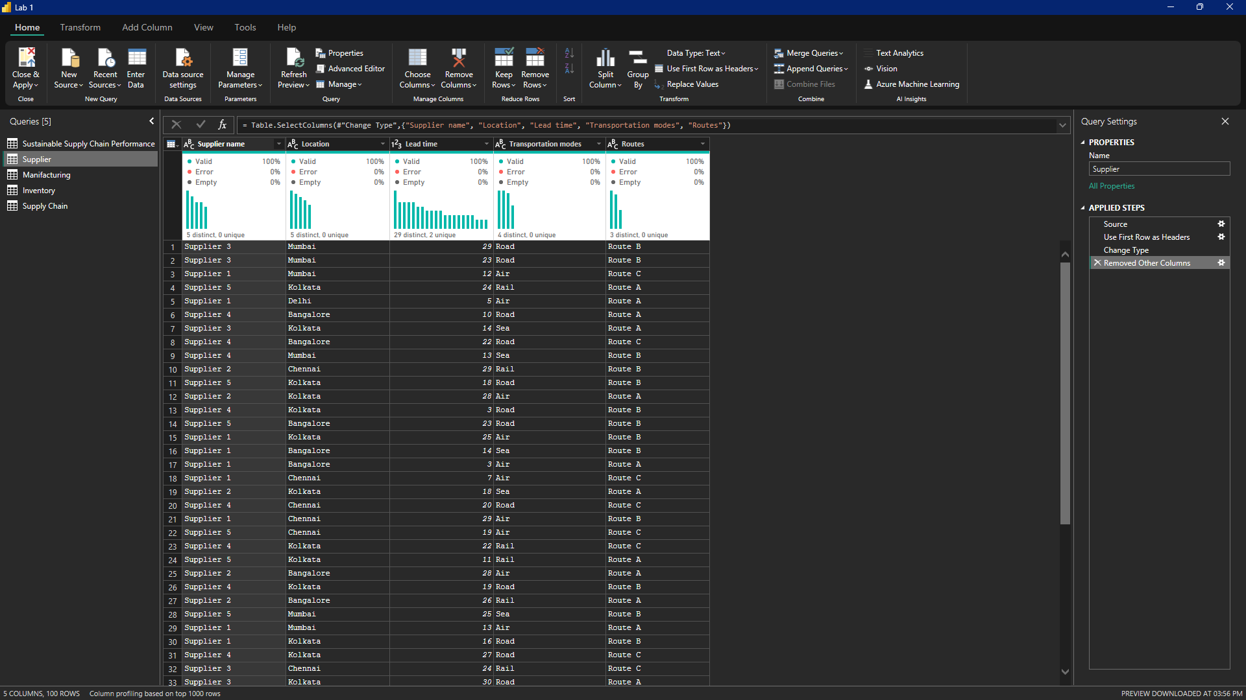

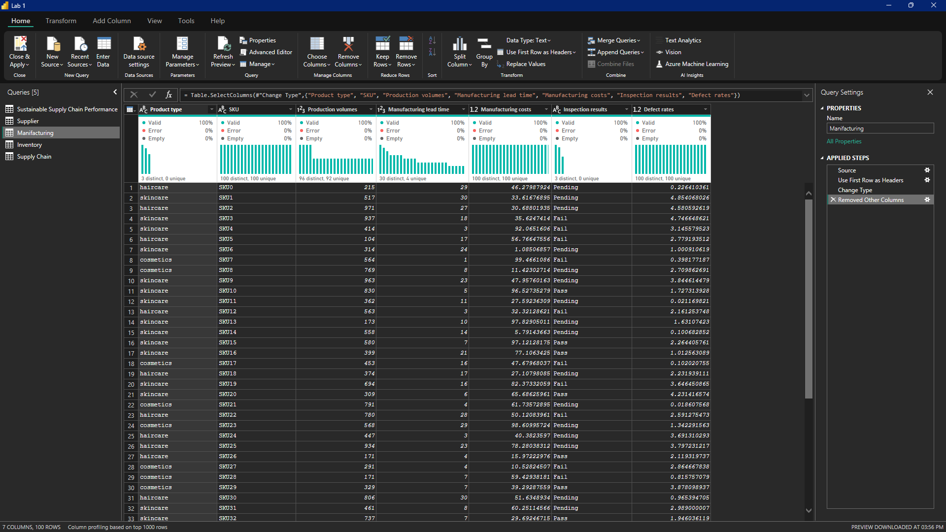

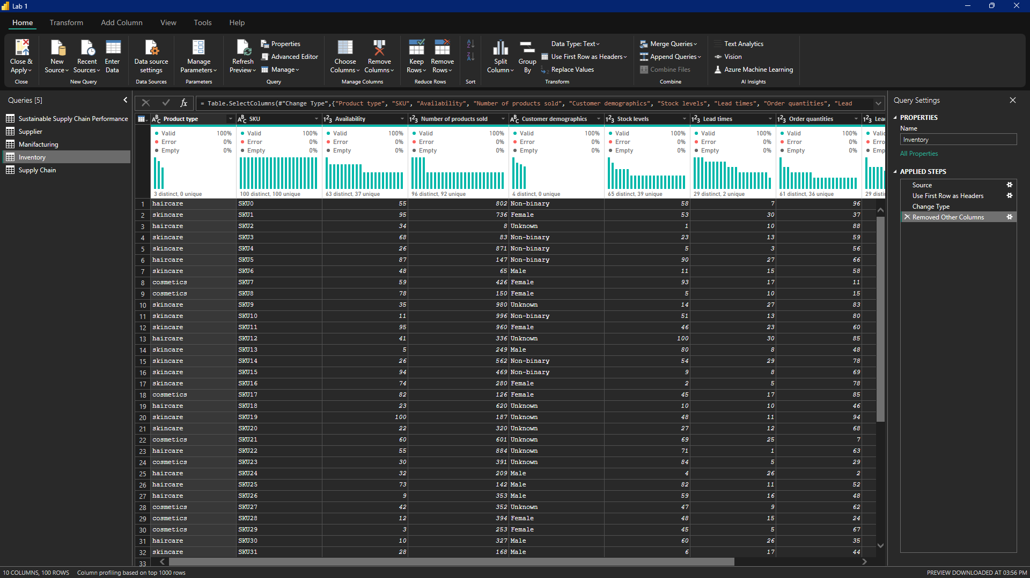

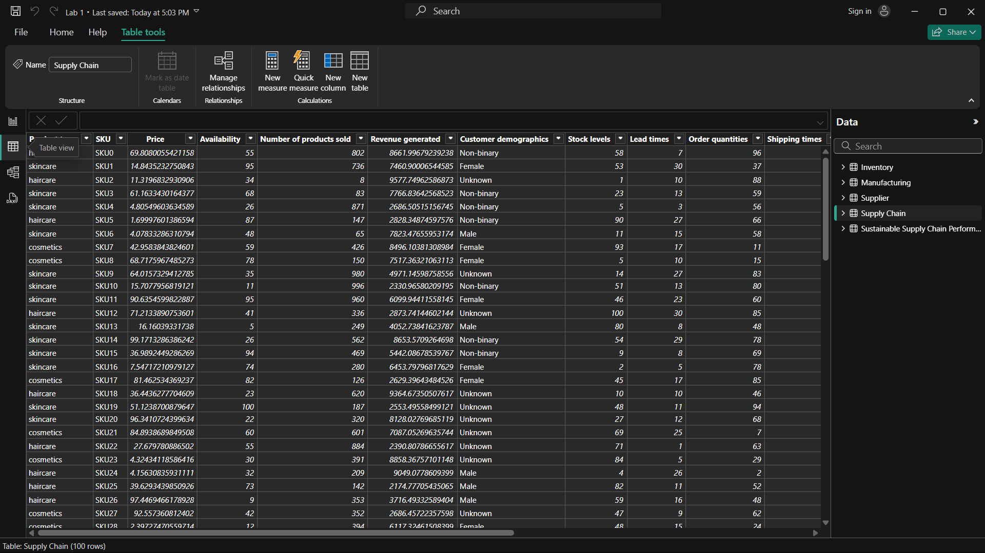

MODEL VIEW

